README

About the Project
This dashboard will facilitate identifying animals that are good candidates for search-and-rescue training. Using data from several animal shelters in the Austin area, the dashboard will help search and filter out animals based on several criteria such as breed, age, sex, etc.

Motivation
When trained, search-and-rescue animals can find and help rescue humans and other animals that are lost, injured, or exposed to other life-threatening conditions. This dashboard was built with selection criteria tailored to the desired qualities for particular types of search-and-rescue animals, making easy to identify good candidates more quickly.
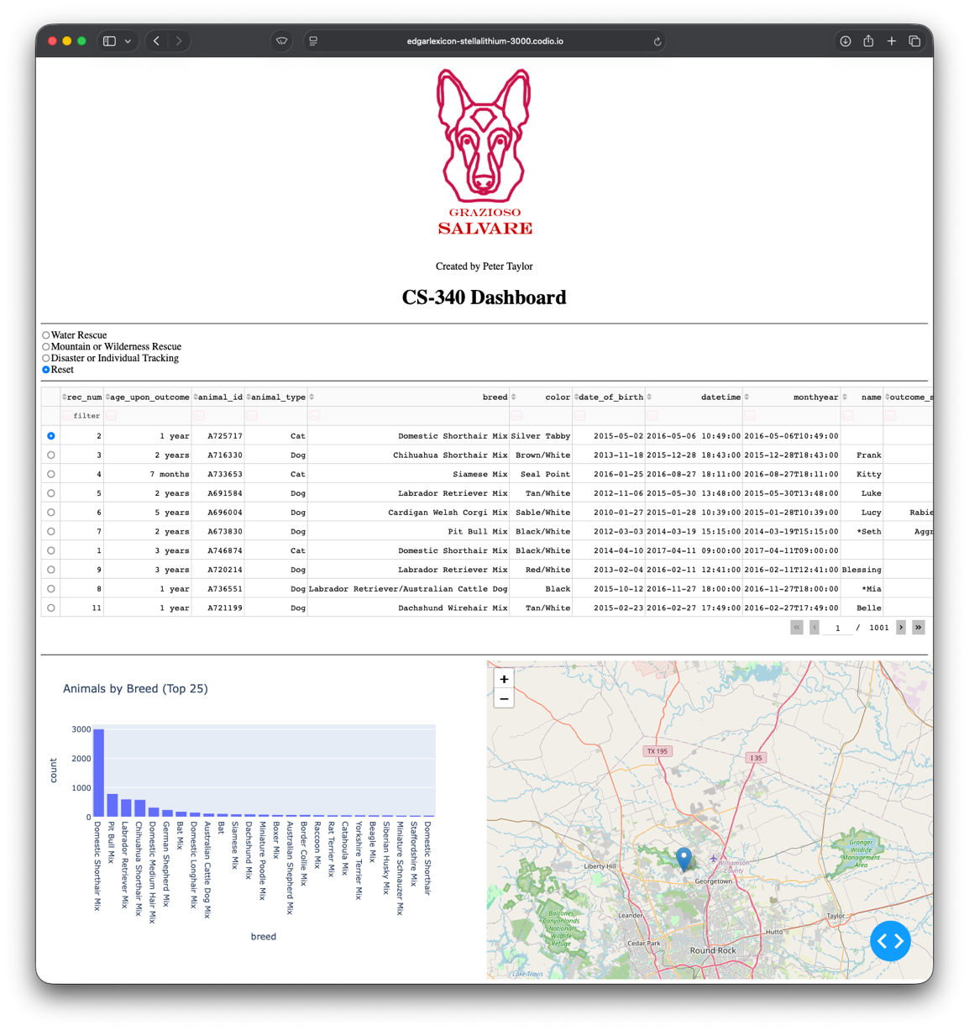

Functionality
The dashboard offers the ability to see the entire database or to filter on key data points. Each column of data has a search textbox that can be used to narrow the displayed animals. Results can also be sorted in ascending or descending order by any column. There is a bar graph that reflects the distribution of animals by breed for the displayed results. Also, when an animal is selected by the radio button in the left column, their location is displayed on the map graphic.
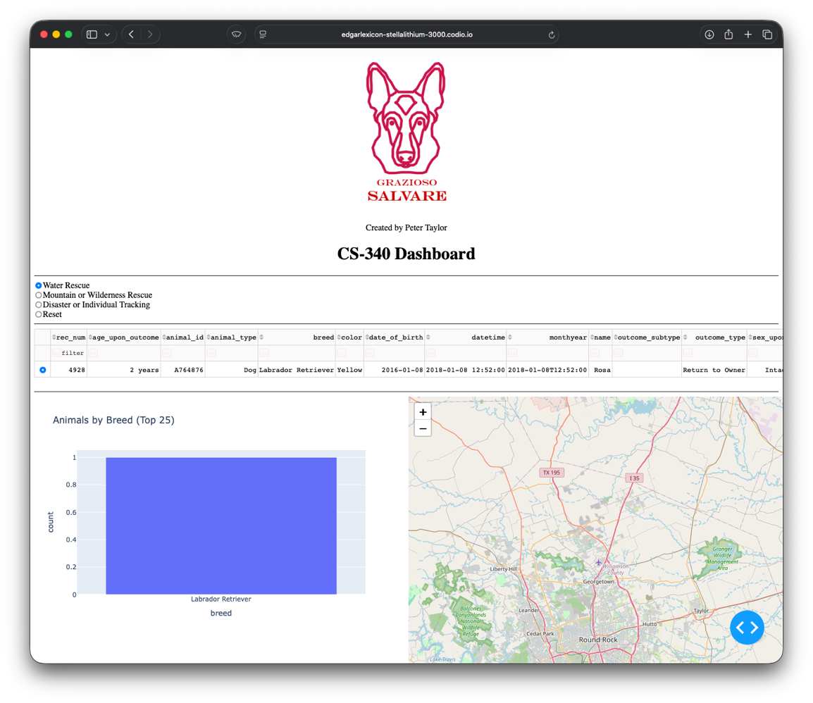
The radio buttons at the top left can be used to select animals suited for particular types of rescue. Selecting “Water Rescue” will display dogs that are ideally suited to be trained for water rescue. This includes intact female Labrador Retriever Mix, Chesapeake Bay Retriever, and Newfoundland breed dogs between 26 and 156 weeks of age.

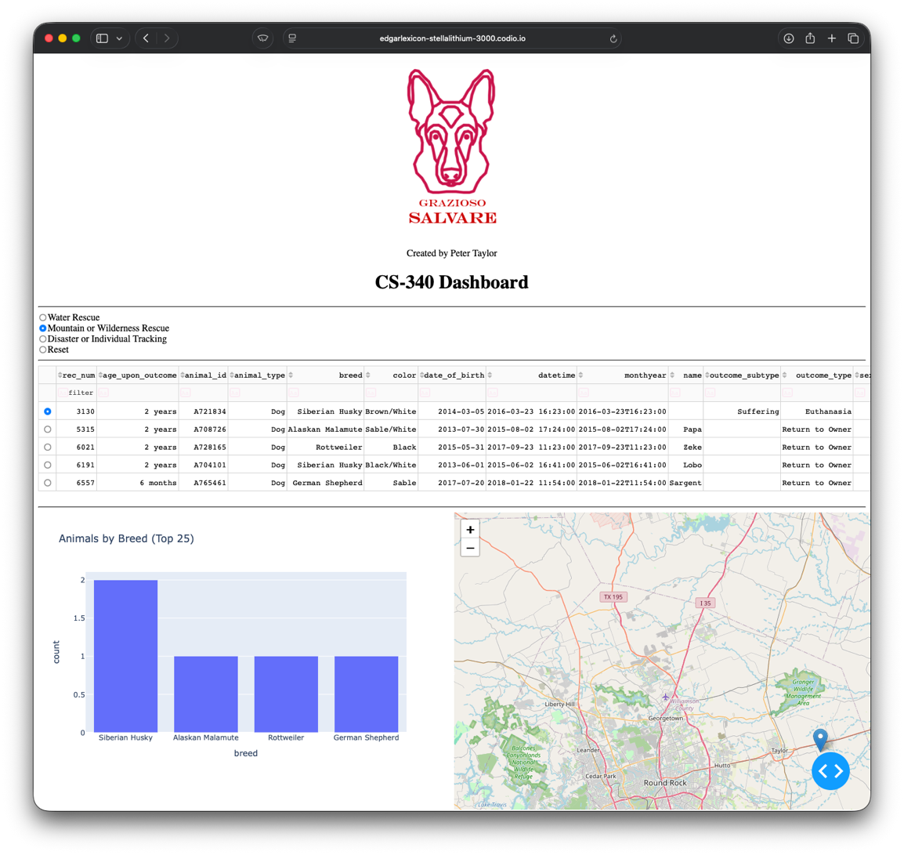
Selecting “Mountain or Wilderness Rescue” will display animals with a high rate of success for this type of training; Intact male dogs between the ages of 26 and 156 weeks of the German Shepherd, Alaskan Malamute, Old English Sheepdog, Siberian Husky, and Rottweiler breeds.

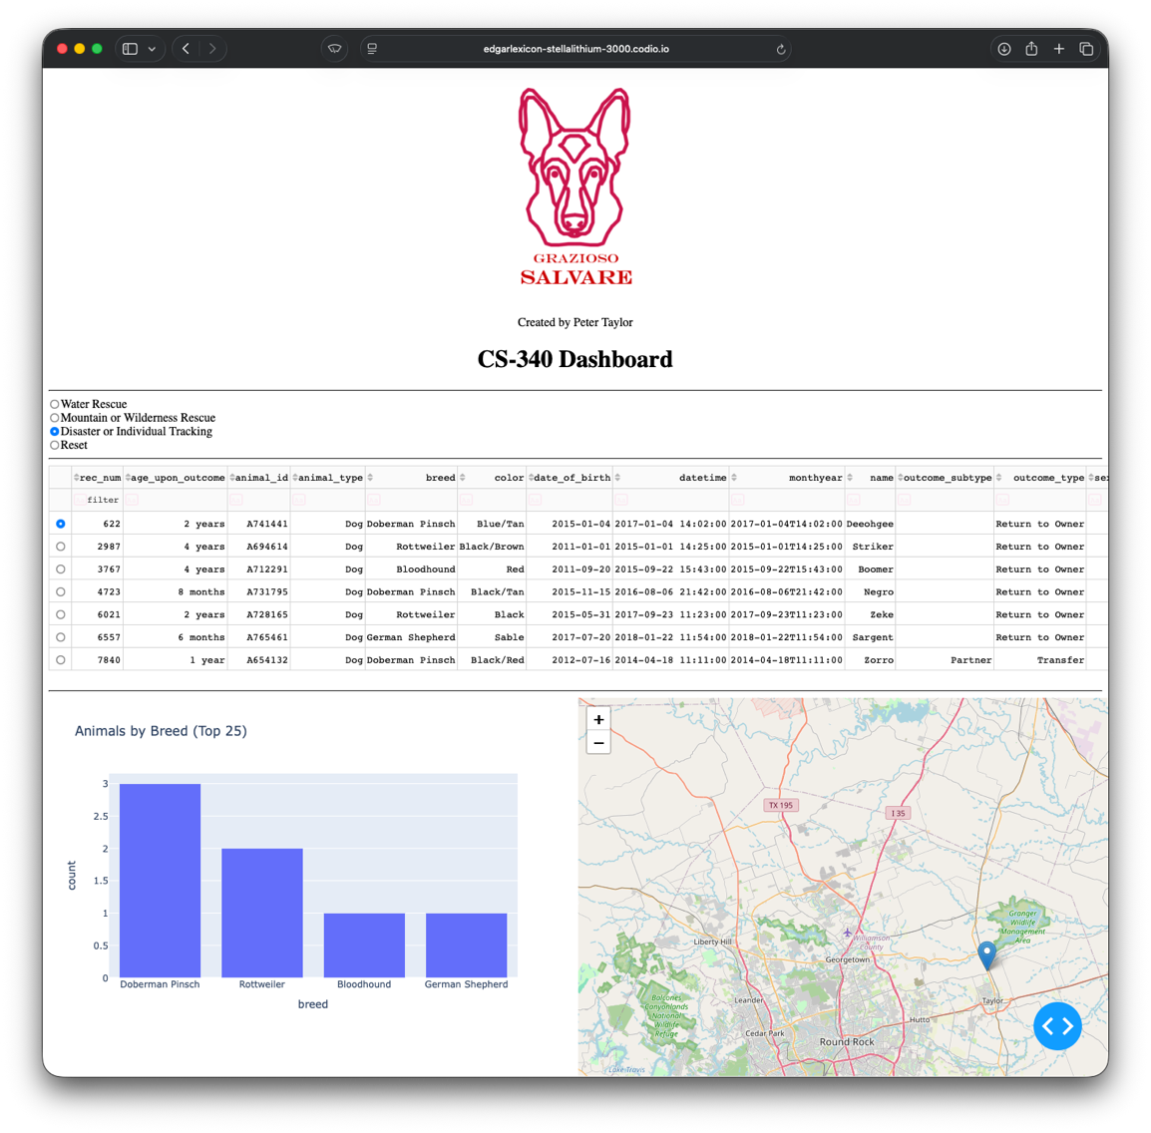
“Disaster or Individual Tracking” displays intact male Doberman Pinschers, German Shepherds, Golden Retrievers, Bloodhounds, and Rottweilers between 20 and 300 weeks of age.

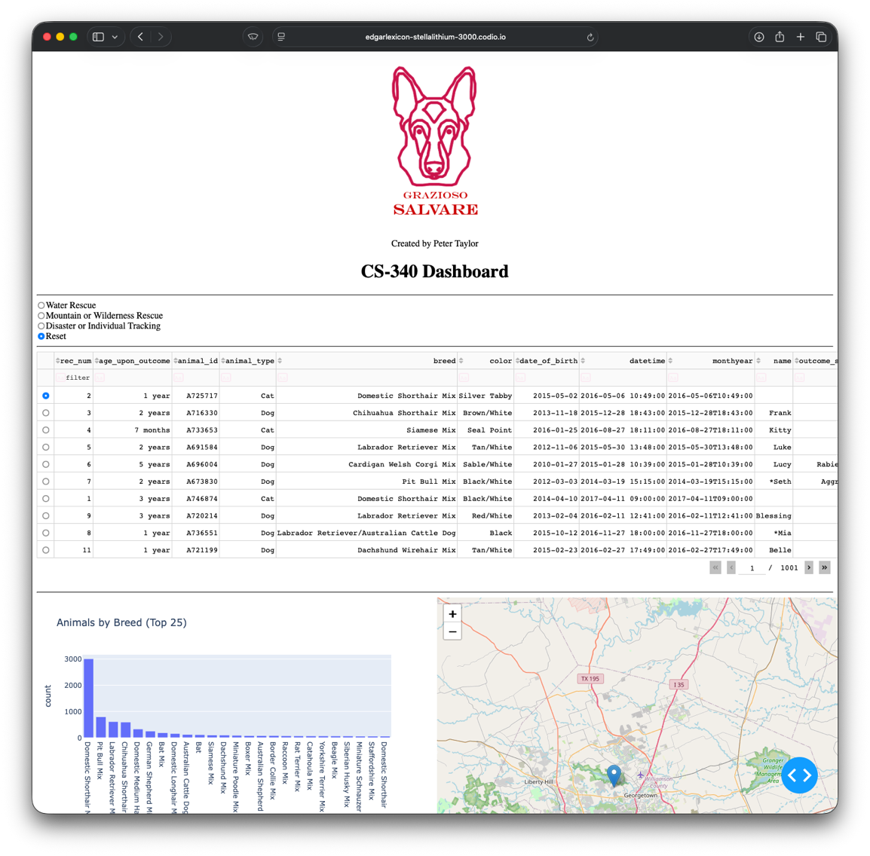
The “Reset” button will show the full list of animals in the database.

Tools Used
MongoDB was chosen as the datastore for this project. It’s schema-on-read document database design makes it easily maintainable in the event that future data sources use different keys for storing data. Since MongoDB uses JSON modeling, it is an ideal solution for an API-driven web application. Coupled with PyMongo, MongoDB makes for fast development time and provides data that can easily be processed and visualized thanks to Pythons strong data analysis tools like Pandas.
Dash is a Python framework that allows developers to quickly build data-driven web applications without the use of JavaScript. It is an ideal choice for this project as it allows the entire reactive frontend to be built in pure Python. Dash provides the view and controller portions of a MVC web application through the use of HTML and CSS type styling and callbacks.
For more information on these tools, check out the official documentation:
https://www.mongodb.com/docs/
https://www.mongodb.com/docs/languages/python/pymongo-driver/current/
https://dash.plotly.com

Development Process
This project was developed in stages. First the CRUD API functionality was built and tested using data imported into a MongoDB database. Authentication was added to both the database and the API.
Once the API was complete and all functions were tested, the main dashboard was developed, and primary display functionality was established and tested. The map widget was integrated and tested after the dashboard was properly displaying data from the database.
Finally, the radio buttons were added the more complex database queries were added to support the specific requirements for each type of rescue animal. The logo and bar chart were added at this stage as well.

Challenges
Overall, I found the project interesting and straightforward. The biggest issue I had was in using a pie chart. While this seemed like a good choice initially for showing the breakdown of results by breed, the sheer number of unique breeds returned in the full dataset made the chart unusable. It took a while to come up with a visualization that might be helpful for the filtered results and still seemed to have value for the full dataset.

Contact
If you have any questions or suggestions, please feel free to reach out to the development team.

Lead Developer: Peter Taylor
peter.taylor3@snhu.edu

